**Description of Current Work**

The Picture 1 shows the visualization of the current work of the traffic simulator. The yellow, blue, and red rectangles indicate the taxis, cars on the right lanes, and cars on the left lanes respectively. The green roads represent the major roads which will have more traffic. If a road is longer than 200 meters (current setting), we mark it a major road. If a road is connecting two major roads, we also mark it a major road.

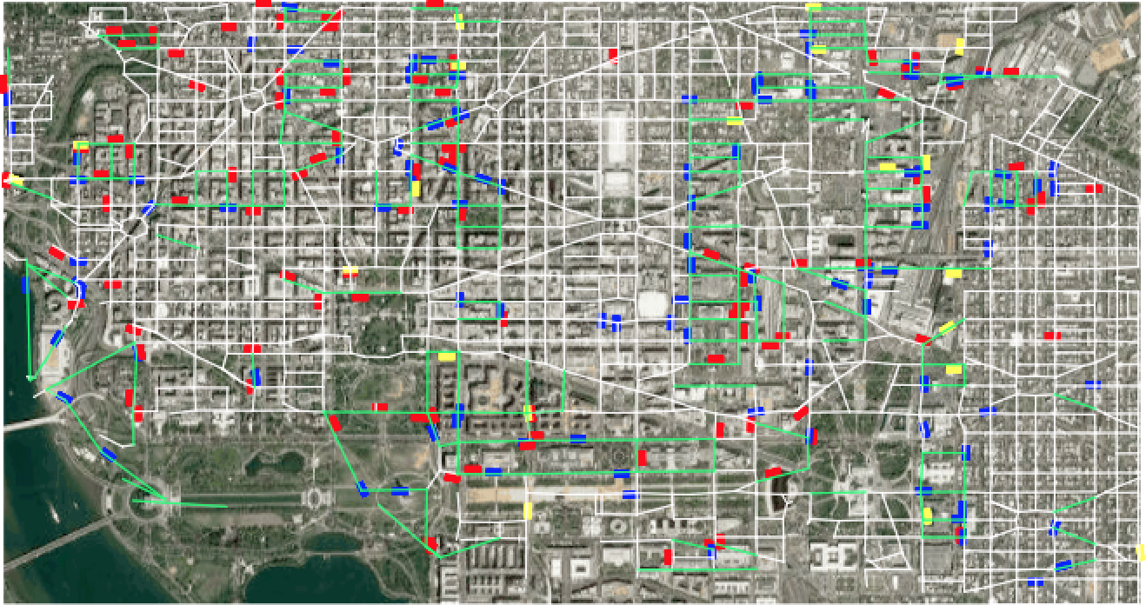

Picture 1. The visualization of the traffic simulator.

For the simulation, when a crash happens (we now fixed the crash location), the simulator will assign the quickest taxi (by estimated arrival time) for the crash event and also call rest of the taxis to go to the same location. The taxis will update their routing every 30 seconds in response to the changes in traffic (the program will find the quickest routing according to the 5-minutes average speed of each road). We also compared the result with that the taxis don't update their routing periodically to see whether the information can help minimized the response time.

|  |
| --- |
|  |

Figure 1. The accumulated number of times of the arrival orders that the called taxi (the quickest taxi the traffic simulator estimated when the crash event happens) arrives the crash location in 10 experiment sets. For example, the called taxi, which updates the navigation every periodically, arrived the crash location at the first order twice, the second order once, and etc.

The experiment results show that with the average speed and updating the navigation periodically, the fastest taxi we found in the beginning will not necessarily arrive first. One possible reason I thought is that the past information (average speed or even a pattern of the traffic) is not enough to guarantee